Report on Different Events of Physical Education
Session-2024-25
In this year students of our department were participated in different sports & athletics competition.
EAST ZONE INTER UNIVERSITRY KHO-KHO(W) CHAMPIONSHIP
University of Kalyani Kho-Kho Women team participated the East Zone championship. In this tournament, five students from our department was the member of the team. This championship was held on 5th to 8th February, 2025 at Vinoba Bhave University, Hazaribag, Jharkand
List of Players:
Sl. No. | Name of the player
1. | Barnali Sarkar
2. | Srijeeta Biswas
3. | Jesmina Mondal
4. | Arfina Mondal
5. | Sangita Sarkar
6. | Mouli Das
7. | Rimpa Mojumdar
8. | Nandini Mondal
9. | Baishaki Biswas

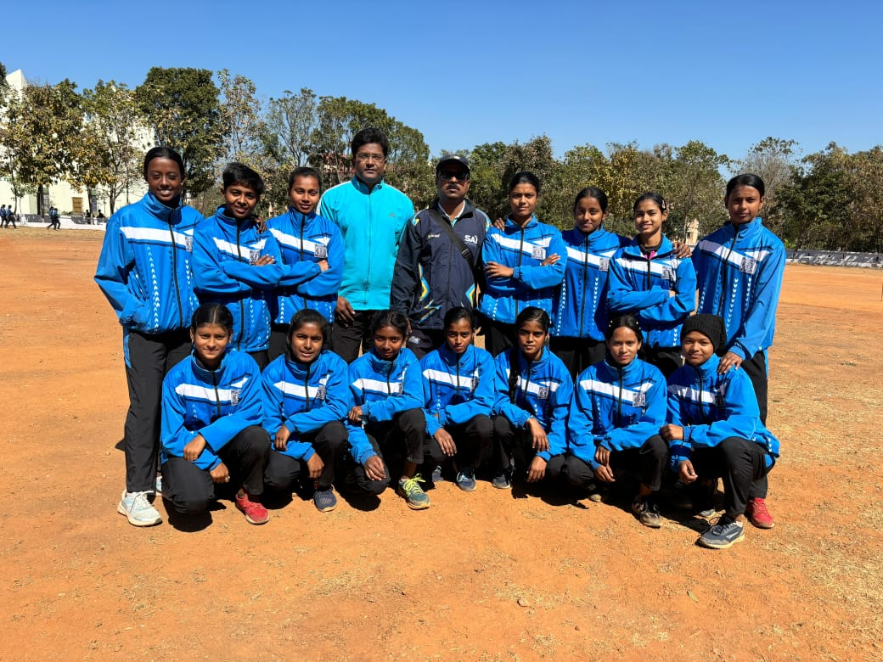

EAST ZONE INTER UNIVERSITRY KHO-KHO(M) CHAMPIONSHIP
In this championship nine students from our department were the member of University of Kalyani Kho-Kho Men team. This championship was held on December, 2024 at Fakir MohanUniversity, Odisha.

List of Players:
Sl. No. | Name of the player
1. | Joydip Biswas
2. | Abhijit Gharami
3. | Rajib Mondal
4. | Arnab Kumar Roy
5. | Samir Sarkar
6. | Bishal Mondal

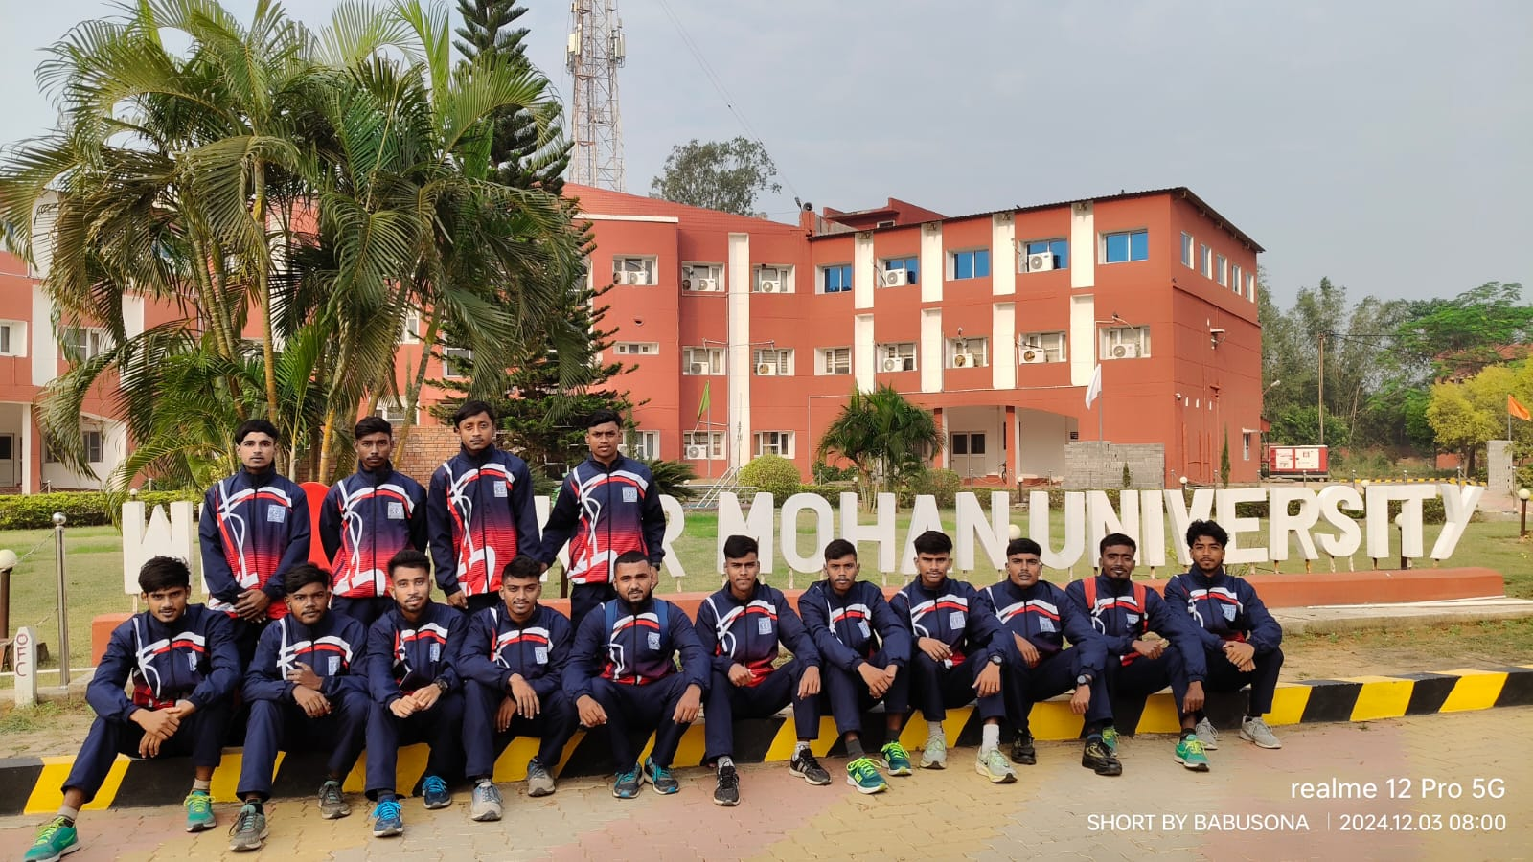

EAST ZONE INTER UNIVERSITRY HANDBALL(W) CHAMPIONSHIP
In this championship four students from our department were the member of University of Kalyani Handball Women team. This championship was held on 17th to 19th February,2025 at Berhampur University, Bhanjabihar, Orissa
List of Players:
Sl. No. | Name of the player
1. | Tapati Biswas
2. | Ranima Mundari
3. | Riya Bhadra

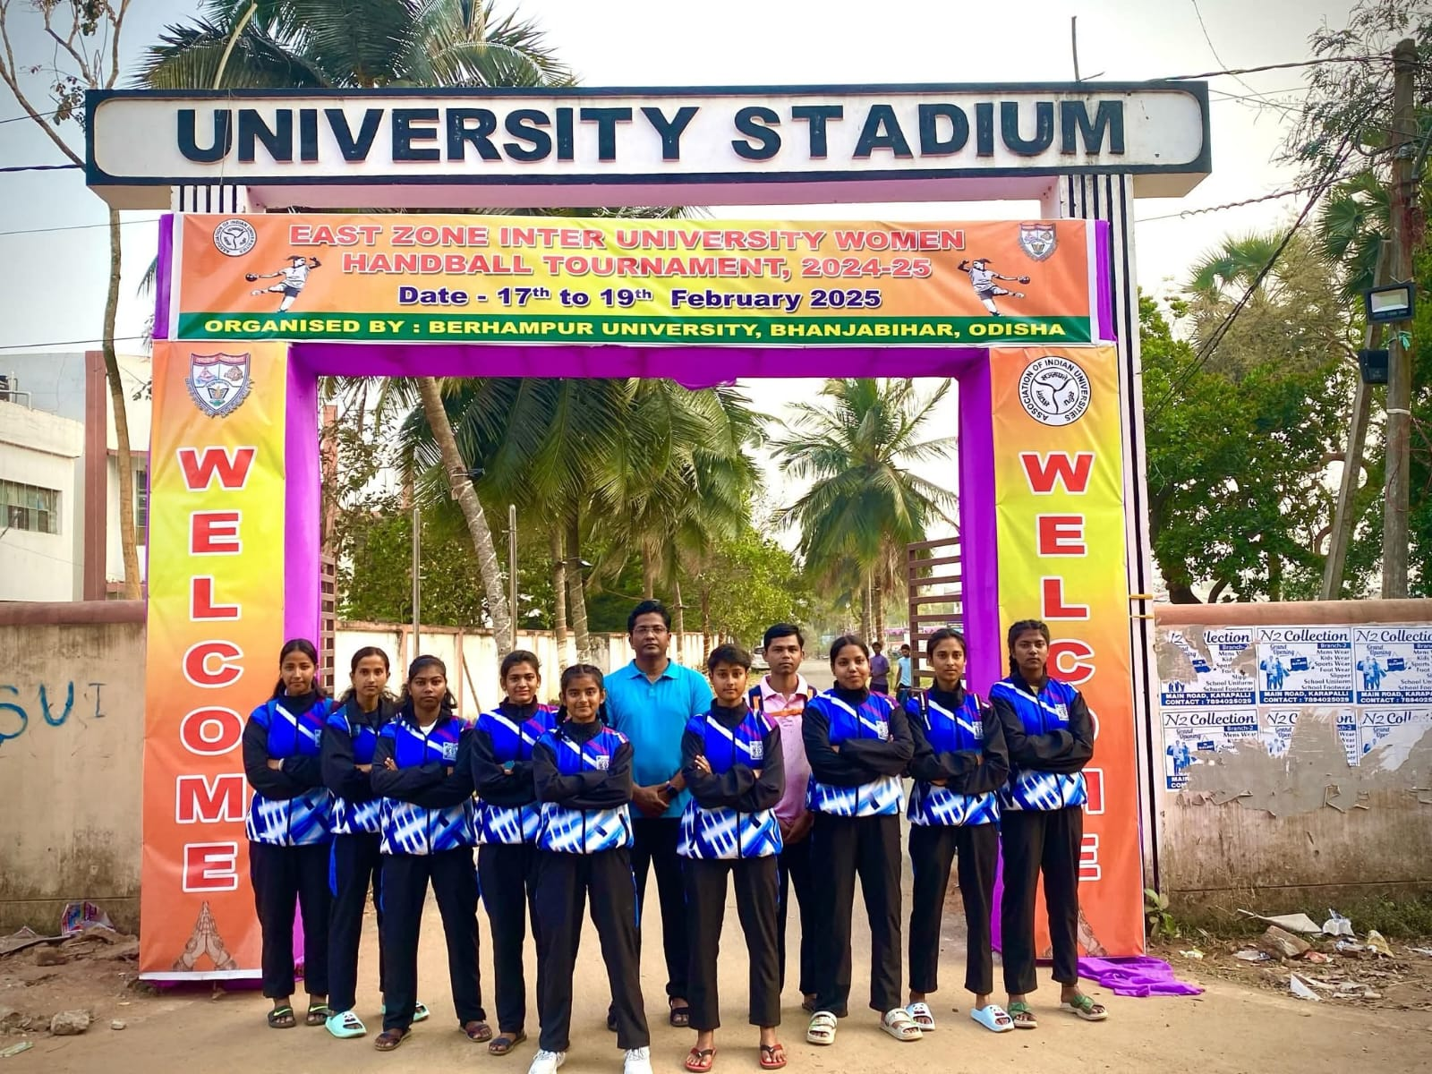

EAST ZONE INTER UNIVERSITRY VOLLEYBALL(M) CHAMPIONSHIP
In this championship one student from our department was the member of University of Kalyani Volleyball Men team. This championship was held on 20th to 23th November, 2024 at Maharaja Sriram Chandra Bhanjadeo University, Odisha.
List of Players:
Sl. No. | Name of the player
1. | Sayan Sarkar

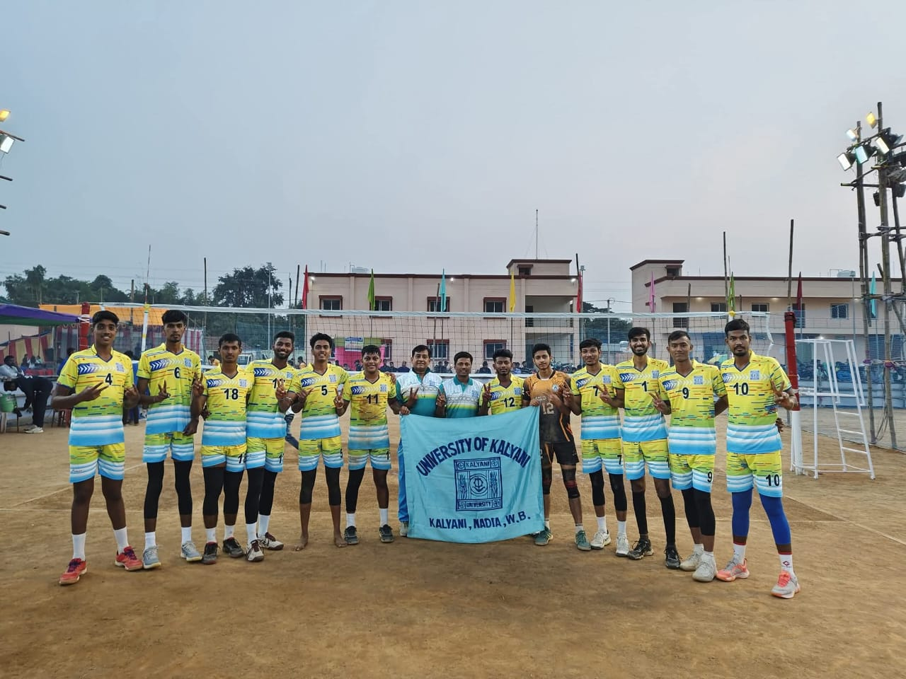

INTER COLLEGE STATE SPORTS & GAMES CHAMPIONSHIP 2024-25 (STATE LEVEL)
KHO-KHO (WOMEN) CHAMPIONSHIP
This championship was organized under the auspices of Education Directorate, Department of Higher Education, Govt of West Bengal and held during the period 20th to 23rd March, 2025 at Sports Authority of India, Netaji Subhas Eastern Centre, Kolkata. Our college team representing Nadia District and securing Runner-up position in this championship.
List of Players:
Sl. No. | Name of the player
1. | Barnali Sarkar
2. | Srijeeta Biswas
3. | Jesmina Mondal
4. | Arfina Mondal
5. | Sana Golder
6. | Murselina Khatun
7. | Sangita Sarkar
8. | Mouli Das
9. | Rimpa Mojumdar
10. | Nandini Mondal
11. | Baishaki Biswas
12. | Puja Bain

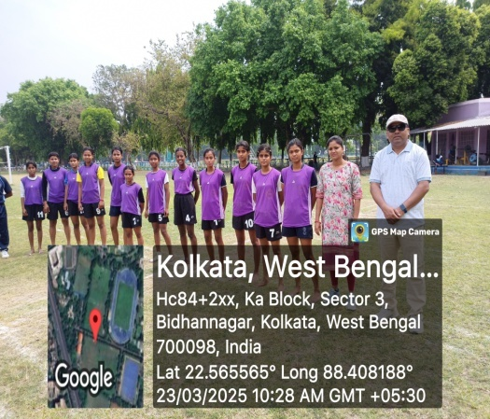 | 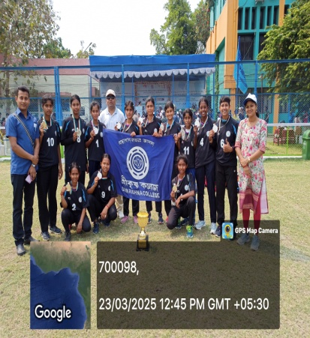 | 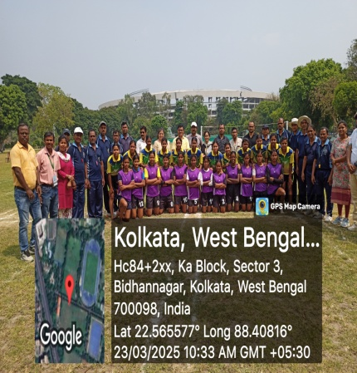

INTER COLLEGE STATE SPORTS & GAMES CHAMPIONSHIP 2024-25 (STATE LEVEL)
ATHLETICS (MEN & WOMEN) CHAMPIONSHIP
This championship was organized under the auspices of Education Directorate, Department of Higher Education, Govt of West Bengal and held during the period 17th to 18th March, 2025 at Sports Authority of India, Netaji Subhas Eastern Centre, Kolkata. From our college six students representing Nadia District Athletics team in this championship and got three medals.

List of Players:
Sl. No. | Name of the player
1. | Ranajit Biswas
2. | Rupam Das
3. | Ankan Dey
4. | Payel Ghosh
5. | Moumita Sarkar
6. | Kunal Roy

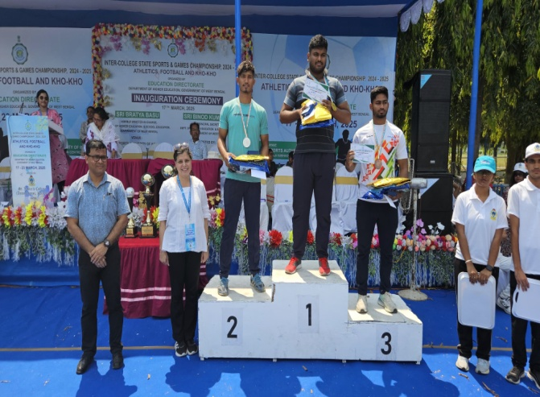 | 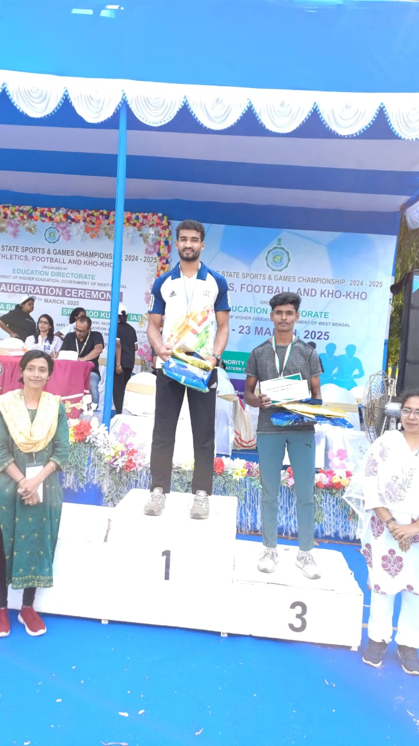

INTER COLLEGE STATE SPORTS & GAMES CHAMPIONSHIP 2024-25 (DISTRICT LEVEL) - KHO-KHO (WOMEN) CHAMPIONSHIP
This championship was organized under the auspices of Education Directorate, Department of Higher Education, Govt of West Bengal and held during the period 10th to 12th February, 2025 at Srikrishna College, Nadia. Our college team winning the champion trophy in this championship.

List of Players:
Sl. No. | Name of the player
1. | Barnali Sarkar
2. | Srijeeta Biswas
3. | Jesmina Mondal
4. | Arfina Mondal
5. | Sana Golder
6. | Murselina Khatun
7. | Sangita Sarkar
8. | Mouli Das
9. | Rimpa Mojumdar
10. | Nandini Mondal
11. | Baishaki Biswas
12. | Puja Bain

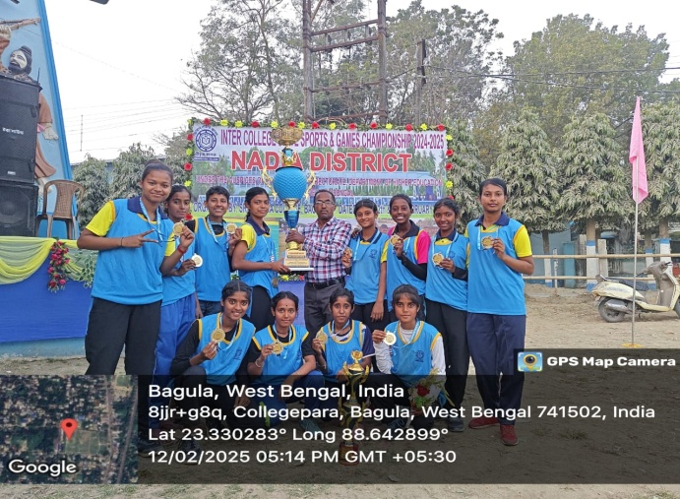 | 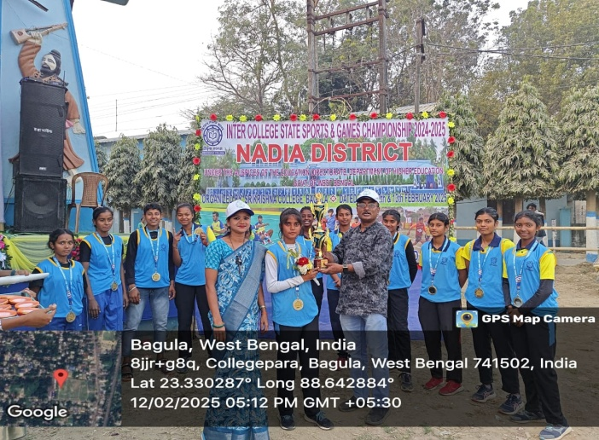

INTER COLLEGE STATE SPORTS & GAMES CHAMPIONSHIP 2024-25 (DISTRICT LEVEL)
ATHLETICS (MEN & WOMEN) CHAMPIONSHIP
This championship was organized under the auspices of Education Directorate, Department of Higher Education, Govt of West Bengal and held during the period 10th to 12th February, 2025 at Srikrishna College, Nadia. Our college athletics (Men & Women) team winning the champion trophy in this championship.

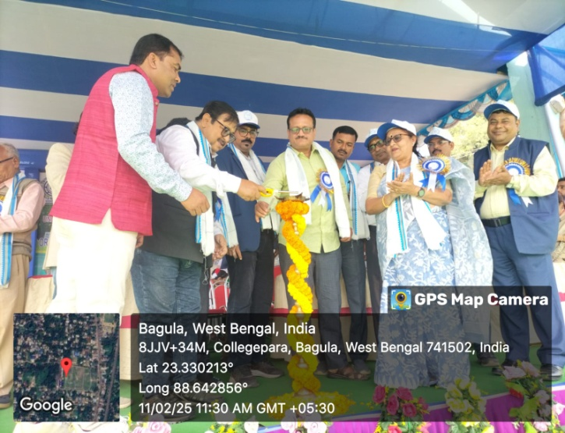 | 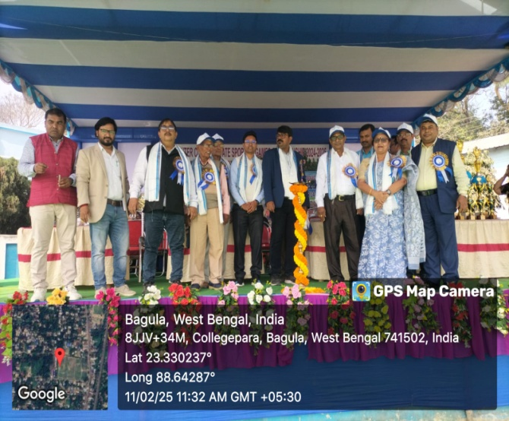

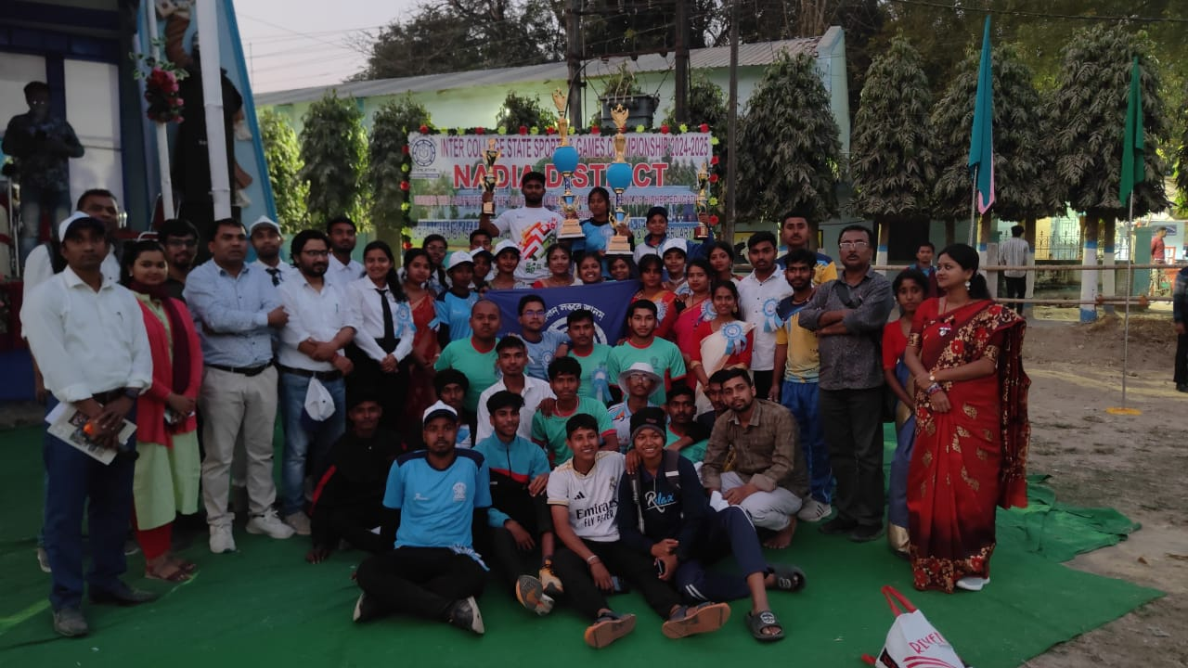 | 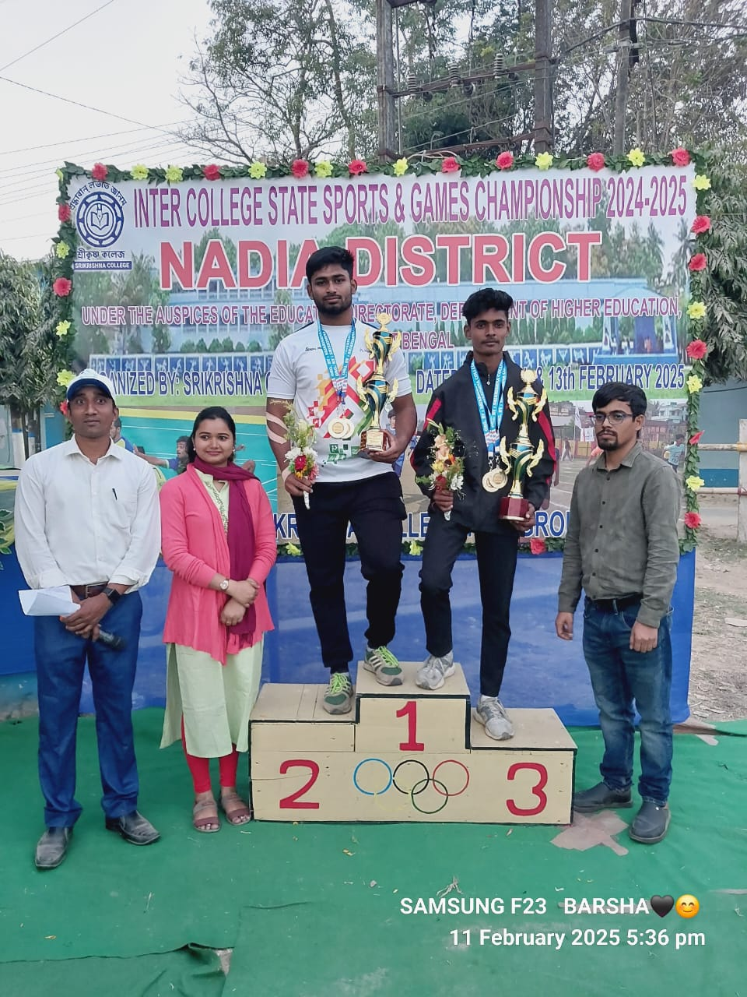

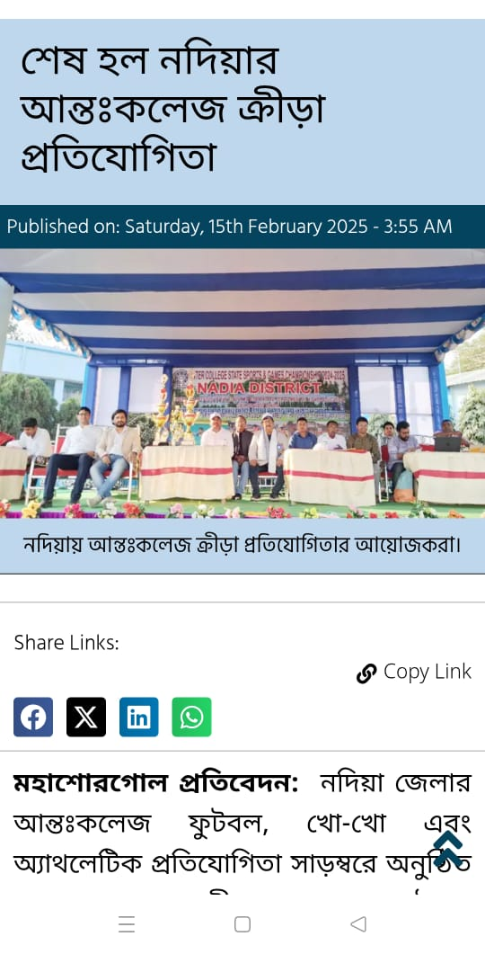 | 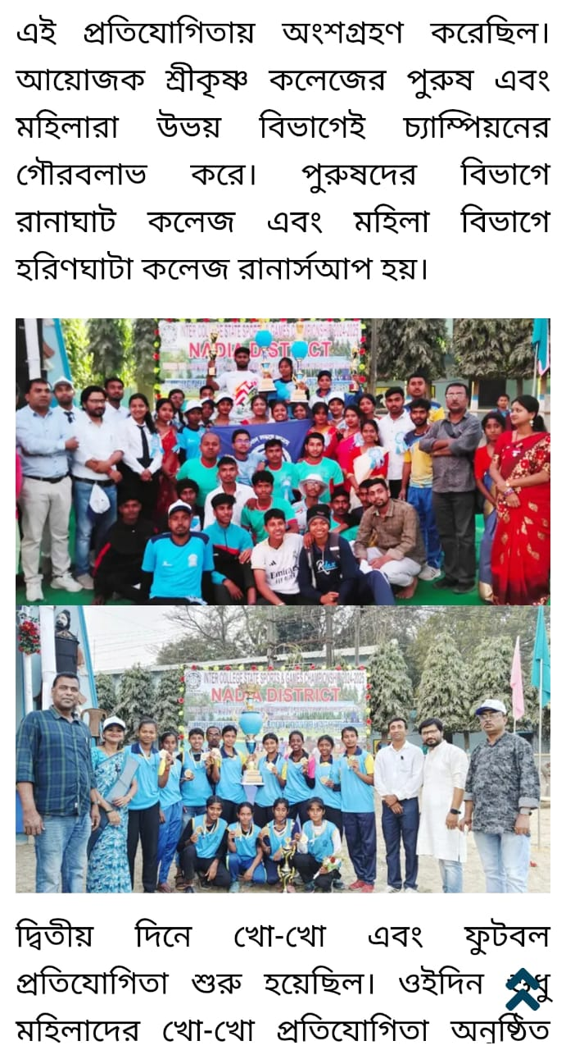

57TH KALYANI UNIVERSITY ANNUAL ATHLETIC MEET 2024-25

Inter College athletic meet under University of Kalyani was organized Sports Council, University of Kalyani, Kalyani, Nadia and held during the period 5th to 6th March, 2025 at Kalyani University playground, Kalyani. From our college 33 students representing in Athletics team in this meet and securing Champion position in this meet.

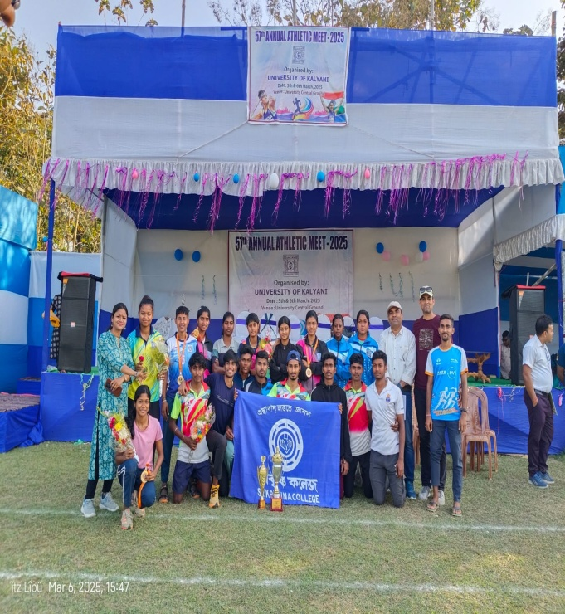 | 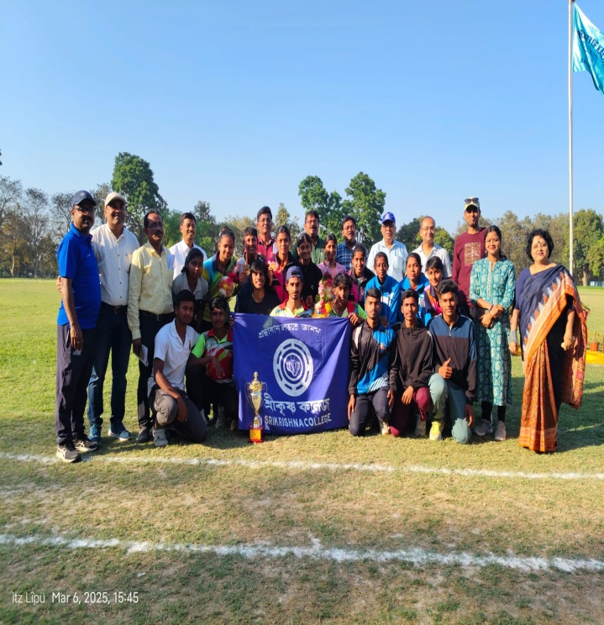

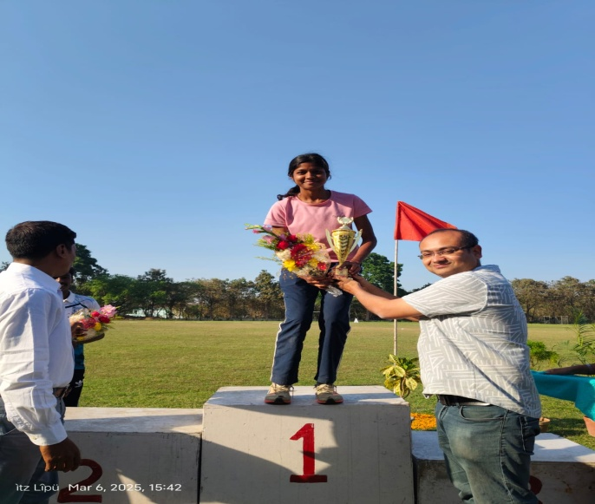 | 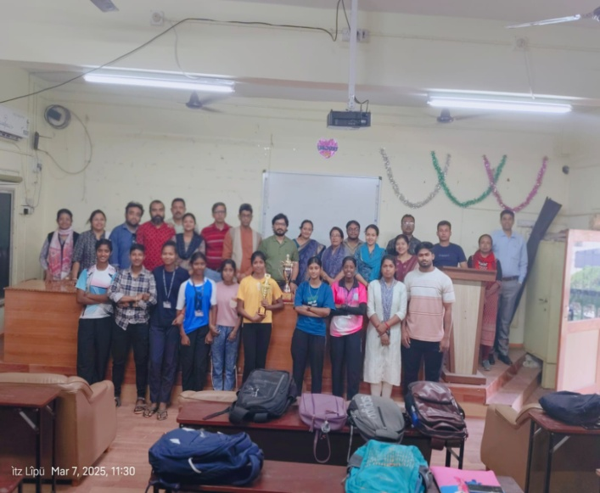

Report prepared by:

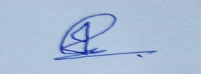
Dr. Md. Imran Hossain
Assistant Professor & HOD
Dept of Physical Education
Srikrishna College, Bagula
Nadia, West Bengal

